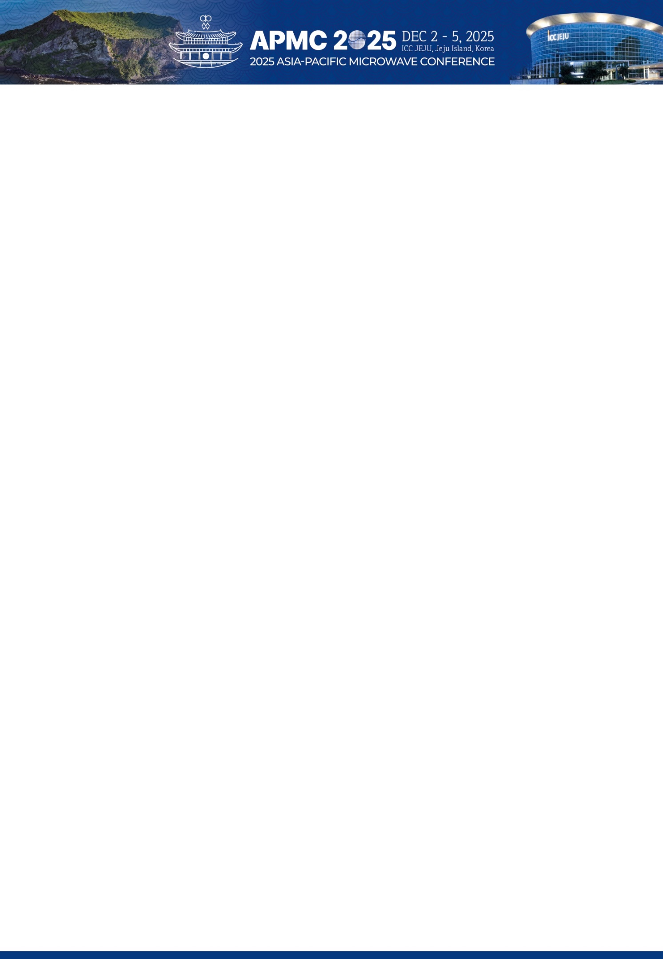

|  |  |  |
| --- | --- | --- |
| **Level** | **KRW** | **Apply (Check “O”)** |
| **Diamond** | **KRW 10,000,000** |  |
| **Platinum** | **KRW 7,000,000** |  |
| **Gold** | **KRW 5,000,000** |  |
| **Silver** | **KRW 3,000,000** |  |
| **Bronze** | **KRW 2,000,000** |  |

|  |  |  |  |
| --- | --- | --- | --- |
| **Company Name** |  | | |
| **Address** |  | | |
| **Website** |  | | |
| **President** |  | | |
| **Contact Person Name** |  | **Job Title / Department** |  |
| **Telephone** |  | **Mobile** |  |
| **E-mail** |  | | |

|  |  |
| --- | --- |
| **Bank Name** | Industrial Bank of Korea |
| **Account Holder** | Korean Institute of Electromagnetic Engineering and Science (APMC)  (KOR) (사)한국전자파학회 (APMC) |
| **Account Number** | 208-017491-04-116 |
| **Swift BIC** | IBKOKRSE |
| **Bank Address** | 79, Eulji-ro, Jung-gu, Seoul, Republic of Korea |

|  |  |
| --- | --- |
| **Exhibition Booth Application** | |
| **□ Yes** | **□ No** |

 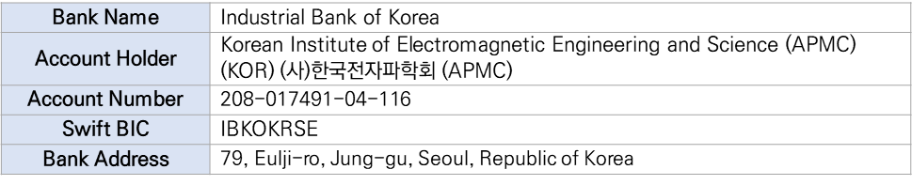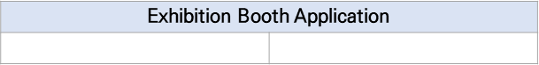

Exhibition Booth Application for the Diamond ~ Silver levels is optional without additional charge on first-come, first-served basis. If you plan for an exhibition booth at APMC 2025, please check the box below.

Please fill out the below application form, and send it back to the secretariat.

**APMC 2025 Secretariat**

E-mail: [secretariat@apmc2025.org](mailto:secretariat@apmc2025.org) / Tel: +82-42-472-7460 / Fax: +82-42-472-7459

**| Company Information**

**| Sponsorship Application**

**| Exhibition Booth (Only for the Diamond ~ Silver levels)**

**| Account Information**

Name of Applicant:

Date:

Signature:

**| Account Information**

Name of Applicant:

Date:

Signature:

**| Exhibition Booth (Only for the Diamond ~ Silver level)**

Exhibition Booth Application for the Diamond ~ Silver level is optional without charge on first-come, first-served basis. If you plan to participate in an exhibition booth at APMC 2025, please check the box below.

Yes

No